#include #include char d; // for DHTII,

// VCC: 5V or 3V

// GND: GND

// DATA: 2

Int pinDHT11 = 8;

SimpleDHT11 dhtl 1 (pinDHT11); LiqujdCgstal void setup() {



led begjn(16, 2);

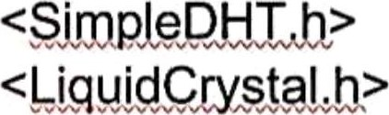void loop() { 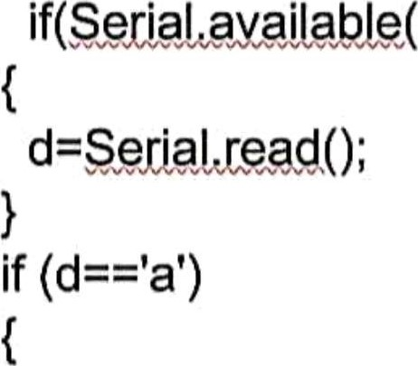if(Serlal

// read without samples. byte temperature = 0; byte humidity = 0;

In! err = SjmpleDvHTErrSuqqess,• if ((err = dhtl 1 .read(&temperature, &humidity, NULL)) !=

SjmpLeDHTErrvSucqæs) { return;

//lcd.setCursor(0,0);

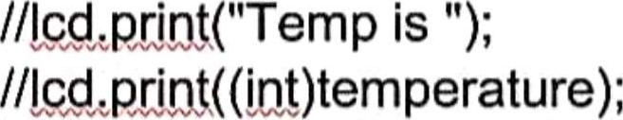 lcuprjnvt(" \*C, "),

//lcd.seßCurspr(0, 1 );

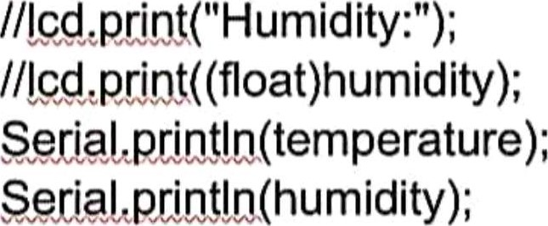

// DHTII sampling rate is IHZ. delay(1500);